Upper Merion Township Library’s
Book Dedication Program
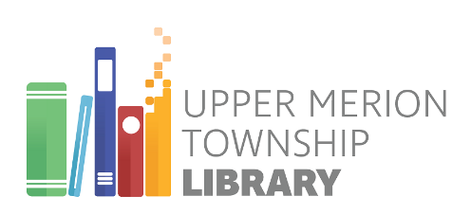
Presented to the
Upper Merion Township Library

In Honor of

By

Date

Dedicating a book at the library is
a great way to celebrate or honor:
- Birthday
- Anniversary
- Mother’s Day/Father’s Day
- Graduation
- Your child’s teacher
- A special friend
- Remember a loved one
- …or just because!

Your gift of a book(s) provides a meaningful and lasting way to celebrate, honor, or remember a loved one. You can do this by donating $25.00 or more to the Upper Merion Township Library. We will purchase a book(s) for you and place a bookplate on the inside cover, acknowledging the names of the recipient and donor. Family or friends of the honored individual will be notified.
Please fill out the form and enclose a check ($25.00 minimum) made payable to Upper Merion Township Library.
For more information call 610-265-4805.
Thank you for your support!

Book Dedication Form

Your Name: ___________________________________________________
Your Address: __________________________________________________
______________________________________________________________
______________________________________________________________
Phone Number: _________________________________________________

Please select one:
____ Special Occasion Dedication
Circle one: Birthday Anniversary Other: ___________________
____ In Honor of: _______________________________________________
____ In Memory of: _____________________________________________
____ Other (write 3-4 word description): _____________________________

Send acknowledgment to:
Name: _______________________________________________________
Address: _____________________________________________________
_______________________________________________________
_______________________________________________________
Phone Number: ________________________________________________

You may suggest a Subject(s) of Interest:
______________________________________________________________________________________

